Press Release

Aachen wins Research Campus –
National Center for Digital Photonic Production
RWTH Aachen was doubly successful in the “Research Campus – Public-Private Partnerships for Innovation” funding initiative by the Federal Ministry of Education and Research (BMBF). The Federal Research Minister Annette Schavan announced that the Aachen research clusters “Digital Photonic Production” and “Future Electric Grids” are among the ten winners of the competition. According to Professor Günter Schuh, Director of the RWTH Aachen Campus GmbH, “this result is a great recognition of our research campus strategy. The competition has adopted about 95 percent of our concept. And that our two most audacious clusters will now receive funding of between 40 to 60 million Euros will give our initiative a further boost. RWTH Rector Ernst Schmachtenberg lauds the success of the two cluster directors, Professors Rik W. De Doncker and Reinhart Poprawe: “In this way, we achieve an even closer alignment of excellent research and industrial innovation.”

The „Research Campus - Public-Private Partnerships for Innovation” initiative is part of the Federal Government’s “High-Tech Strategy for Germany.” Within a research campus cluster, universities, research institutions and companies join forces to collaborate on challenging long-term research topics. Each research cluster receives funding of up to two million Euros per year, for a maximum funding period of 15 years. It is required that the participating partner institutions also contribute substantial funds to the joint research project.

Digital Photonic Production
„Light as a Tool in Production“ – that is the key research area of the “Digital Photonic Production” research cluster. The aim is to use lasers in production and manufacturing processes, especially for applications in the fields of mobility, energy, health, and information and communication technology. Innovative technologies such as laser-based production processes are highly promising, and a high-profile consortium at RWTH, together with partners from research institutions, industry and SMEs, now sets out to exploit this potential in a systematic long-term collaboration. As Rainer Poprawe, RWTH Chair for Laser Technology, comments: “We are pleased that we at the BMBF Research Campus Cluster ‘Digital Photonic Production,’ in collaboration with more than 20 partners from business and industry, can contribute to this paradigm shift."

Future Electric Grids
Under the leadership of the E.ON Energy Research Center, the “Eco-Friendly Sustainable Energy” cluster is currently being developed to include the “Future Electric Grids” research campus cluster. This unit focuses on the investigation of direct current grids for the transmission and distribution of power. With their long-term research strategy, RWTH Aachen and its partners from industry, including leading companies, seek to contribute to securing sustainable energy supplies in the future, both nationally and internationally. As professor Rik W. De Doncker, Director of the E.ON Energy Research Center, puts it, “electric grids currently constitute a bottleneck for Germany’s energy transformation process. The research campus cluster makes it possible for us to develop the grids of the future and to thus contribute to Germany’s renewable energy program.”

Further information concerning the funding initiative “Research Campus”:
www.forschungscampus-deutschland.de

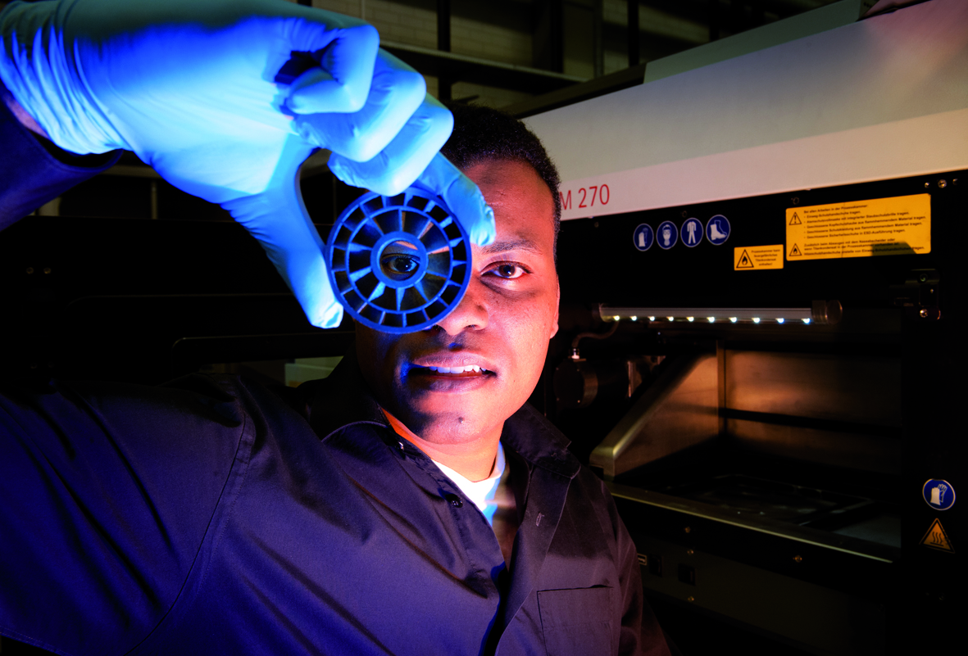 | Digital Photonic Production – the quick and efficient way to individualized components.  Picture Source:  DAAD/Volker Lannert.

The Fraunhofer-Gesellschaft is the leading organization for applied research in Europe. Its research activities are conducted by 60 Fraunhofer Institutes at over 40 different locations throughout Germany. The Fraunhofer-Gesellschaft employs a staff of around 20,000, who work with an annual research budget totaling 1,8 billion euros. Roughly two thirds of this sum is generated through contract research on behalf of industry and publicly funded research projects. Branches in the USA and Asia serve to promote international cooperation.

For further information
Dipl.-Phys. Christian Hinke | RWTH Aachen Campus Cluster Photonic Production | Phone +49 241 8906-352 |
christian.hinke@ilt.fraunhofer.de | Fraunhofer Institute for Laser Technology ILT, Aachen, Germany | www.ilt.fraunhofer.de
Celina Begolli | RWTH Aachen University Press Office | Phone +49 241 80-92324 | Pressestelle@zhv.rwth-aachen.de
RWTH Aachen University | Templergraben 55, 52056 Aachen, Germany | www.rwth-aachen.de
Dieses Feld, sowie die Tabelle auf der letzten Seite nicht löschen!

