Press Release

LaserCUSING in an XXL format for the carmaker Daimler
Fraunhofer ILT and Concept Laser develop a laser fusing machine on a super scale for the automotive industry

Additive manufacturing with metals is becoming increasingly important in the automotive industry. Time and cost reductions in production are making this generative technology increasingly attractive to the carmakers. The primary focus is on aluminium alloys which provide the basis for lightweight automobile construction. For applications involving vehicle and engine technology, but also from other areas, Daimler AG is now consistently embracing the resource-efficient, generative metal laser melting of metals. In order to meet all future assignments, the Swabia-based company got the Fraunhofer Institute for Laser Technology (ILT) and the LaserCUSING specialist Concept Laser to develop a new super laser melting machine X line 1000R whose build chamber size surpasses anything that was known previously.

The Fraunhofer ILT from Aachen and Concept Laser from Lichtenfels are presenting the new high-performance LaserCUSING® machine X line 1000R for fabricating series components in an XXL format to the general public for the first time at Euromold 2012 (hall 11, stand D88). A first machine is already in operation at Daimler AG.

Pilot machine on a mega scale
The large machine X line 1000R boasts a superlative build chamber which, according to Frank Herzog, managing director of Concept Laser, has impressive dimensions. The X line 1000R was developed for the tool-less manufacturing of large functional components and technical prototypes with material properties which are identical throughout the range. The centrepiece of the X line 1000R consists of a high-power laser in the kilowatt range which enables an increase in productivity of up to a factor of 10 compared with standard laser fusing machines available on the market.

Develop complex components faster
The machine was specifically configured to cater for Daimler AG's special requirements for automobile applications. The aim of Daimler AG was to replace costly sand-casting and die-casting applications in early phases of development. In addition, the LaserCUSING process will in future offer the possibility of generating lightweight structures with a high level of rigidity which will permit weight-optimised geometries, with almost no restrictions on the design, but at present cannot be manufactured in this way with the manufacturing techniques which are available today.

Cooperation between Daimler, Fraunhofer ILT and Concept Laser
The project partners got together as part of the "Alu generative research and development project (German Ministry of Education and Research)“. The Fraunhofer ILT examined, together with different partners from industry, including Daimler AG, the laser fusing technology for production applications involving aluminium components. The industrial use for fabricating production components was previously, mainly as a result of the materials and costs, restricted to smaller components or dental and medical technology. As part of the project, the application potential for manufacturing aluminium components for other areas of industry was examined. The well-known characteristics of the production process include conservation of resources, independence from mould-making, freedom of geometry, as well as the speed of construction and development. The examinations were appraised at Daimler as a fundamentally new way of looking at manufacturing options with the aim of creating innovative and environmentally friendly products. From the point of view of the development partners, these also provided a solid basis for tackling the pressure of costs in production and safeguarding Germany's long-term future as a place for high-tech manufacturing.

Requirement in automotive construction
The demands of Daimler AG as an industrial partner were a significant increase in the build-up rates, an improvement in the quality of the surface finish, reproducibility and reliability of the machine as a result of appropriate process monitoring, as well as the qualification of further aluminium series alloys for a range of applications. The Fraunhofer ILT, which has been one of the leading research institutions in the field of laser melting for over 15 years, supplied its know-how for designing the kW laser beam source and the matching optical lens system in order to ensure the desired build-up rates of different aluminium alloys. In addition, the process control for processing the different alloys alongside the machine construction was worked out and the mechanical properties of the components were examined.

Concept Laser as a machine constructor
The preliminary work now needed to be turned into "solid" machine technology. In parallel with this, the functional specification was drawn up at Concept Laser in Lichtenfels together with the partners and the design phase for the new X line 1000R was then started. The findings which had been obtained in the meantime by the Fraunhofer ILT, e.g. in relation to temperature control of the build chamber in order to avoid any warping in the "oversized" components, and in relation to the design of the powder application system were consistently implemented in the design of the X line 1000R. "This really was uncharted territory for us. The development of a machine concept of these dimensions in close collaboration with Daimler AG and the Fraunhofer ILT, based on our LaserCUSING® technology, clearly illustrates our claim to be the technology leader in the field of laser melting. This patented, top-class machine technology from Concept Laser has been exported throughout the world since 2000. As a result of the cooperation project with Daimler and the Fraunhofer ILT, we hope that the generative machine technology will meet customers' requirements on a broad basis and that it can be employed profitably," says Frank Herzog in reflecting on the cooperation project. For the development of parts at Daimler AG, the high and flexible availability of such a machine opens up entirely new possibilities for further optimisation of the product development process.

Background info on LaserCUSING®
The LaserCUSING® process, equivalent to the Selective Laser Melting (SLM) process, is used to produce metallic components which can be subjected to mechanical and thermal loading with high precision. Depending on the application, the materials used are high-grade and tool steels, aluminium or titanium alloys, nickel-based superalloys, cobalt-chromium alloys and in future precious metals such as gold and silver will also be used.
Description of the process
LaserCUSING® involves fine metallic powder being locally fused by a fibre laser. Following cooling, the material solidifies. The contour of the component is produced by directing the laser beam using a mirror deflecting unit (scanner). The component is built up layer by layer (with a layer thickness of 20 – 100 μm) by lowering the bottom of the installation space, applying more powder and fusing again. The special feature about the machines from Concept Laser is stochastic navigation of the slice segments (also referred to as "islands") which are processed successively. The patented process ensures a significant reduction in stresses within the component.

Overview of Concept Laser

CONCEPT LASER GmbH is a company belonging to the Hofmann Innovation Group in Lichtenfels (Germany). Since the year 2000, the company has been regarded as a pioneer in the field of generative metal laser fusing technology. With the LaserCUSING® process, the company is involved in all different sectors of industry.

The term LaserCUSING®, made up of the letter C from CONCEPT LASER and the word FUSING (complete melting), describes the technology used: the fusion process generates components layer by layer using 3D CAD data.

The generative process allows complex component geometries to be produced without the use of any tools right through to complex structural geometries which are very difficult to produce, if they can be produced at all, using conventional techniques.

The LaserCUSING® process allows the fabrication of both mould inserts with close-contour cooling and direct components for the medical, dental, automotive and aerospace sectors. Both prototypes and mass-produced parts are manufactured.

Standard machines and customer-specific machine concepts for the LaserCUSING® of metals are on offer. Full service as an option at Concept Laser means that customers can purchase machines for their own independent LaserCUSING® application, or access services and development expertise (prototypes and small batches) directly.

The laser processing machines from Concept Laser process powder materials from high-grade and tool steels, reactive aluminium or titanium alloys, nickel-based superalloys, cobalt-chromium alloys and in future will also process precious metals such as gold and silver.

LaserCUSING® opens up new perspectives in terms of quality, reproducibility, economic viability and speed for more efficient product development in sectors such as:

- Medical and dental technology
- Aerospace industry
- Tool making
- Automotive/motor racing
- Mechanical engineering

The machines make it possible to shorten development times and reduce development costs considerably. The key benefits of LaserCUSING® include greater freedom of geometry, coupled with much greater flexibility in terms of product development. Another central advantage of the process is the opportunity to produce components without the use of tools and the obviation of the machine programming associated with this.

The high quality standards, many years of experience and references of Concept Laser are synonymous with process-reliable and cost-effective solutions which demonstrate their efficiency in everyday production. Thanks to ongoing further development, the unit costs of the generative process are constantly being reduced.

In 2011, Hofmann Innovation GmbH generated sales of EUR 60 million with 500 employees.

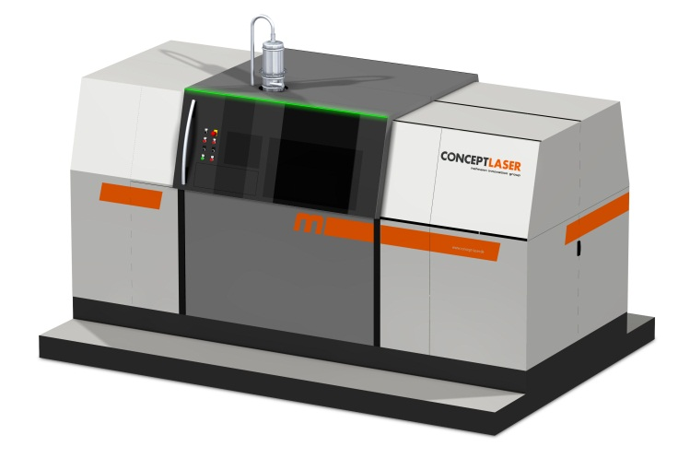 | Fig. 1:  Superlative LaserCUSING: The X line 1000R has a superlative build chamber.  Picture Source:  Concept Laser.

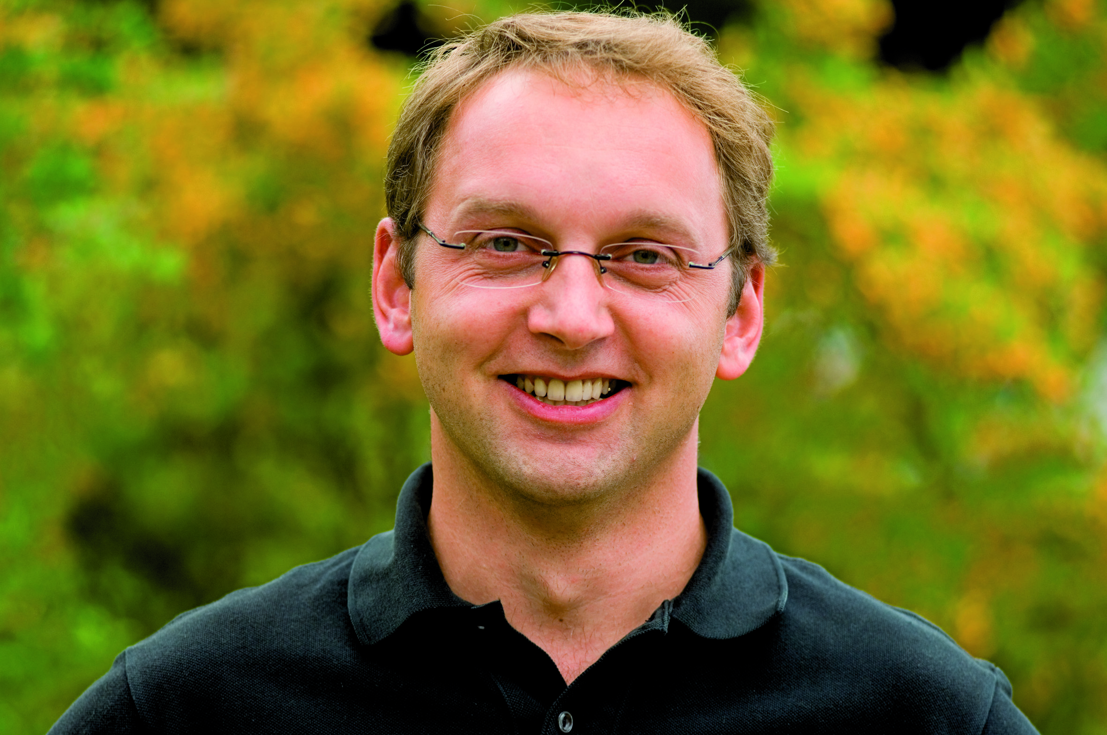 | Fig. 2:  "As a result of the cooperation project with Daimler and the Fraunhofer ILT, we hope that the generative machine technology will meet customers' requirements on a broad basis and that it can be employed profitably," comments Frank Herzog, CEO of Concept Laser.  Picture Source:  Concept Laser.

The Fraunhofer-Gesellschaft is the leading organization for applied research in Europe. Its research activities are conducted by 60 Fraunhofer Institutes at over 40 different locations throughout Germany. The Fraunhofer-Gesellschaft employs a staff of around 20,000, who work with an annual research budget totaling 1,8 billion euros. Roughly two thirds of this sum is generated through contract research on behalf of industry and publicly funded research projects. Branches in the USA and Asia serve to promote international cooperation.

For further information
Ilona Scholl | Head of Marketing and Communications of the Concept Laser GmbH | Phone +49 9571 949-238
i.scholl@concept-laser.de | Concept Laser GmbH | An der Zeil 8 | 96215 Lichtenfels, Germany | www.concept-laser.de
Dr. Wilhelm Meiners | Head of the Group Rapid Manufacturing | Phone +49 241 8906-301
wilhelm.meiners@ilt.fraunhofer.de | Fraunhofer Institute for Laser Technology ILT, Aachen, Germany | www.ilt.fraunhofer.de
Dipl.-Ing. Damien Buchbinder | Rapid Manufacturing | Phone +49 241 8906-488
damien.buchbinder@ilt.fraunhofer.de | Fraunhofer Institute for Laser Technology ILT, Aachen, Germany | www.ilt.fraunhofer.de
Dieses Feld, sowie die Tabelle auf der letzten Seite nicht löschen!

